Weak reference Proposal for Java Script

Since from nearly 4 years, there is long debate of Weak Reeference in the Java Script. Now a days, this became a hot topic between my collegues, so thought of adding up some notes here. So what is this Weak Refference :

According to the Wiki (https://en.wikipedia.org/wiki/Weak_reference) :

In computer programming, a weak reference is a reference that does not protect the referenced object from collection by a garbage collector, unlike a strong reference. An object referenced only by weak references – meaning "every chain of references that reaches the object includes at least one weak reference as a link" – is considered weakly reachable, and can be treated as unreachable and so may be collected at any time.

The above wiki exaplntation is good, but lets understand this with some simple example:

var client, serviceObject;
client = serviceObject = document.querySelector('demo')
client = undefined
// ... a GC pause later …
//If you observe, client dereferrnced the DOM element,
//but, serviceObject still references the DOM element
In the diagram below – retrieved from the proposal’s repository – the target Object in the below diagrm is the DOM Element “Demo”. Now, consider a use case like this, a core component called as “Client” referrence the DOM element and another one or more secondary service Components which are only necessary as long as the DOM element is being referenced.
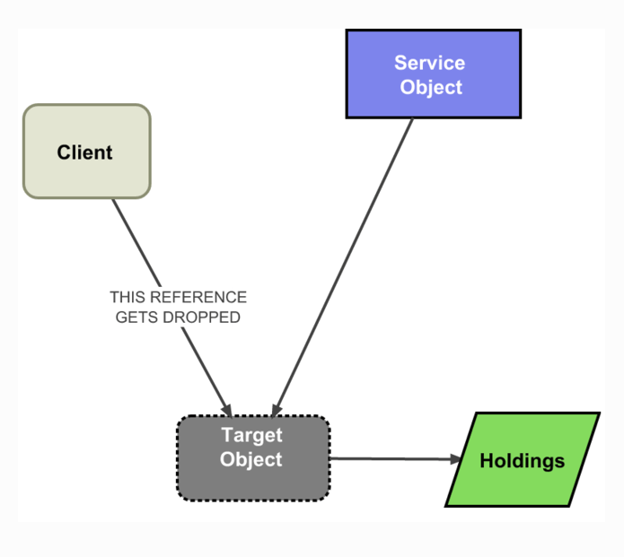

That means, we have to deffernce the serviceObject, when ever the core component (in the above example, client) dereference the Target Object. In the present java script implementation, this does not exists. Ok, if it doesnot exists, what kind of problems it arises? Lets see some real world examples:

- Historically the lack of weak references has resulted in various solutions in libraries like jQuery, specifically designed to avoid cycles being created between event listeners and DOM objects. Many of these solutions are error-prone and require manual breaking of cycles.
- Data Binding in the MVC frameworks
- MVC frameworks often use an observer pattern: the view points at the model, and also registers as an observer of the model. If the view is no longer referenced from the view hierarchy, it should be reclaimable. However in the observer pattern, the model points at its observers, so the model retains the view (even though the view is no longer displayed)
- Caches that require cleanup after keys are no longer referenced

Expected proposal Implementation

As per this proposal, we can have two related enchancements to the language runtime:

- Weak references
- A weak reference is a reference that allows access to an object that has not yet been garbage collected, but does not prevent that object from being garbage collected
- Finalization
- Finalization is the execution of code to clean up after an object that has become unreachable to program execution.

Under this proposal, we will have new class called as “WeakRef” and a global function makeWeakRef (which helps to create WeakRef object, which points to the target). So, if the target is no longer referenced, then the WeakRef object will stop pointing at it after a full garbage collector sweep.

makeWeakRef(target, executor?, holdings?)

The parameters to makeWeakRef are as follows:
- target is the object we wish to create a weak reference to
- executor is an optional argument that can be used as a finalization callback
- holdings is an optional argument provided to executor when it’s invoked for target
WeakRef Object has two methods:
- get() - which retrieves the weakly held target object reference or null if the object has been garbage collected away
- clear() - which nulls out the underlying weak reference while preventing the executor from being invoked, without the need for a full GC sweep.
So, the above example, can we written in this way using the WeakRef:

var target = document.querySelector('demo')
var weakRef = makeWeakRef(target)
if(weakRef.get() === target) // If thier atleast one non-weak reference, get() return sthe target element
{
console.log(“I am still pointed to the target”);
}
//Now de-referrence the target as follows:
target = undefined
//Now after the Full GC, WeakRef no longer points to the target, so WeakRef of get is null
if(WeakRef.get() === null) {
consolde.log('As the target is de-reference so am I');
}
In the above code snippet, we waited for the GC sweep, if you want to immeditely break the weakly held reference, you can use “clear” method, as follows:
//Now de-referrence the target as follows:
target = undefined
WeakRef.clear();
if(WeakRef.get() === null) {
consolde.log('As the target is de-reference so am I');
}

How this proposal is different from WeakMap
WeakMap are just a subset of the Map, which holds references to its keys weakly, meaning that if there are no other references to one of its keys, the object is subject to garbage collection.
If you go thru above line once again, this is not excatly same as the Weak Reference. A WeakMap doesn't give weak references to objects-- it is not the values that are weak references in WeakMap, but the keys. The fact that weak references exist in the map is only a memory leak prevention mechanism, and is not observable to the user otherwise.
WeakMaps and WeakRefs address mostly disjoint use cases. On one hand, We cannot use WeakRefs to fully emulate the GC virtues of WeakMaps and on the another hand, WeakMaps cannot be used to make an object accessible only until it is not otherwise referenced. Also WeakRef are deterministic and can be made freely available to unprivileged code and WeakMaps are non-deterministic, GC decisions visible. Separating these abstractions clarifies both.
Reasons why WeakRefs Implemenation is Postponing
One of the good reason is, secuirty issues. Accroding to the TC39 (Ecma International, Technical Committee 39 – ECMAScript), has a general policy against features that allow garbage collection to be visible to applications.
Lets check this some simple use case as follows:
Given a master actor M that can communicate with two independent actors A and B (but A cannot communicate with B).
- M passes a frozen object O to A.
- A then creates a WeakRef for O.
- A also strongly holds on to O.
- M then passes the same object to B.
- B creates another weak ref to O.
- Now B will get notified when A stops holding strongly to O
- This leads to a communication channel.
Node-weak
I thought, it is worth mentioning this module in this context. Node-weak module, exports V8's Persistent<Object> functionality to JavaScript. That means, we can create the Weak Refferences now in Javascript using this module and also, we can pass callback functions to it, so that they get invoked right before the Object is garbage collected.
You can check this module on this link at GitHUb: TooTallNate/node-weak (https://github.com/TooTallNate/node-weak ). Check the below simple example,which explains what it does (Copied the below code snipet from above Github link):
var weak = require('weak')

// we are going to "monitor" this Object and invoke "cleanup"
// before the object is garbage collected
var obj = {
a: true
, foo: 'bar'
}

// Here's where we set up the weak reference
var ref = weak(obj, function () {
// `this` inside the callback is the EventEmitter.
console.log('"obj" has been garbage collected!')
})

// While `obj` is alive, `ref` proxies everything to it, so:
ref.a === obj.a
ref.foo === obj.foo

// Clear out any references to the object, so that it will be GC'd at some point...
obj = null

//
//// Time passes, and the garbage collector is run
//

// `callback()` above is called, and `ref` now acts like an empty object.
typeof ref.foo === 'undefined'

